Lab3 Milestone 1 By E. Zhou & Q. Pang

Checkpoint 1.

1. Screen shot: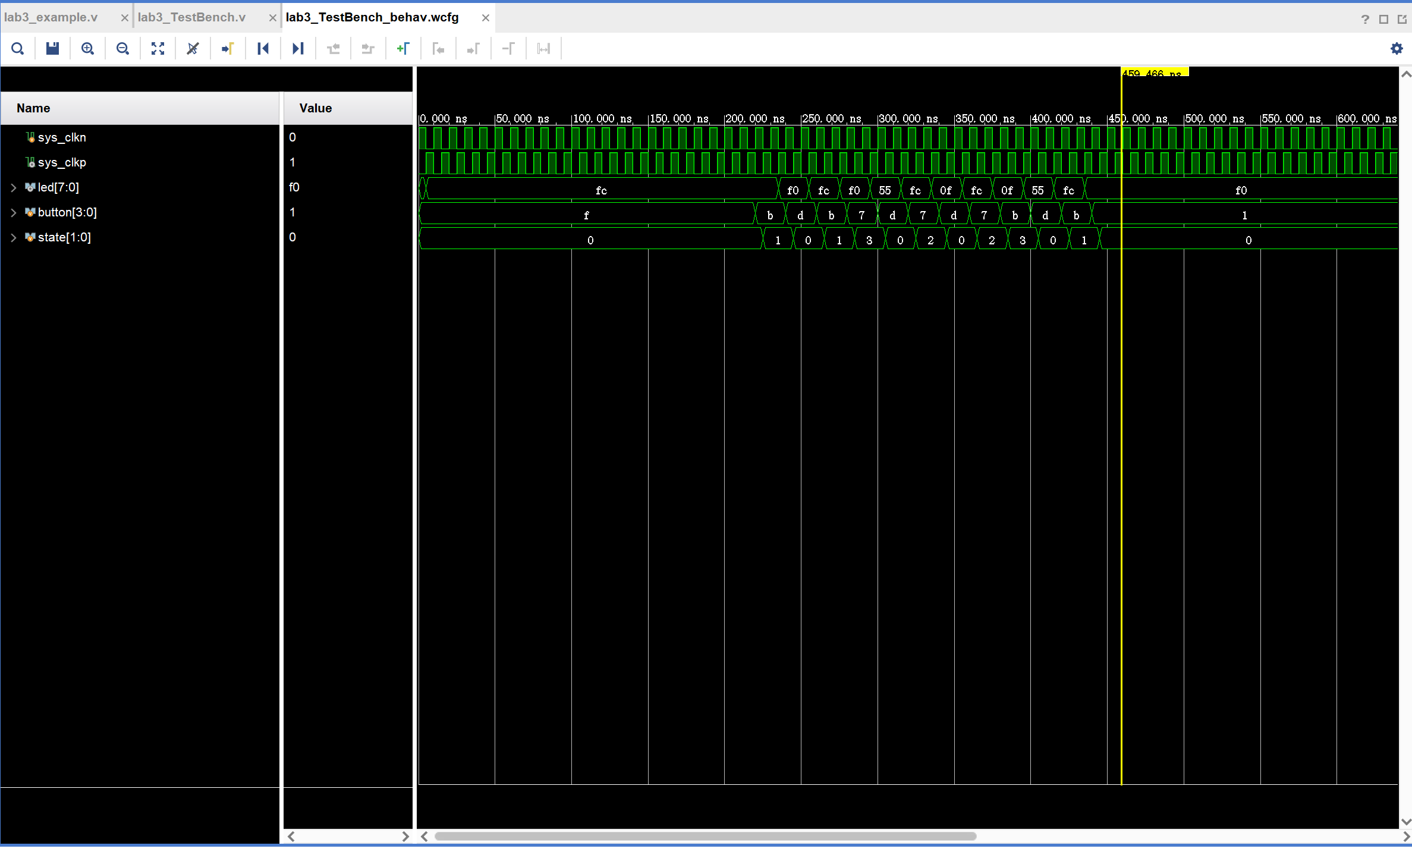
2. a. The led output (and there for led_register) is floating (undefined) initially and requires the first falling edge to become valid in the post implementation timing simulation while in behavior simulation it is valid immediately, this showcases signal setup time.

b. All bits in the led output does not update at the same time, they change at different time due to different signal delays.

c. Signals also does not update perfectly aligned with clock edges in post implementation timing sim, while signals edges aligned perfectly with clock edges in behavioral sim

Behavioral simulation:

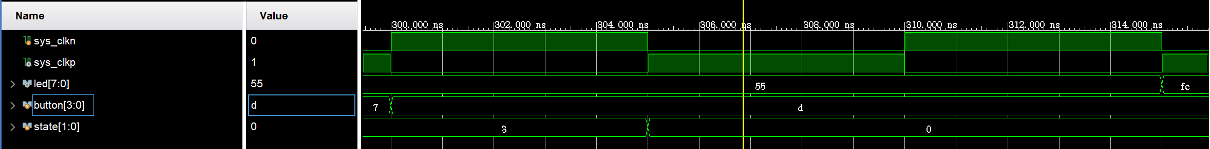

Post implementation timing simulation:



1. It takes roughly 25ns for LEDs to change its output, there is some erroneous state between state transition, this is due to each bit of the leds output going through different amount of levels of combinational logic to be updated thus having different delays, updating at different times. 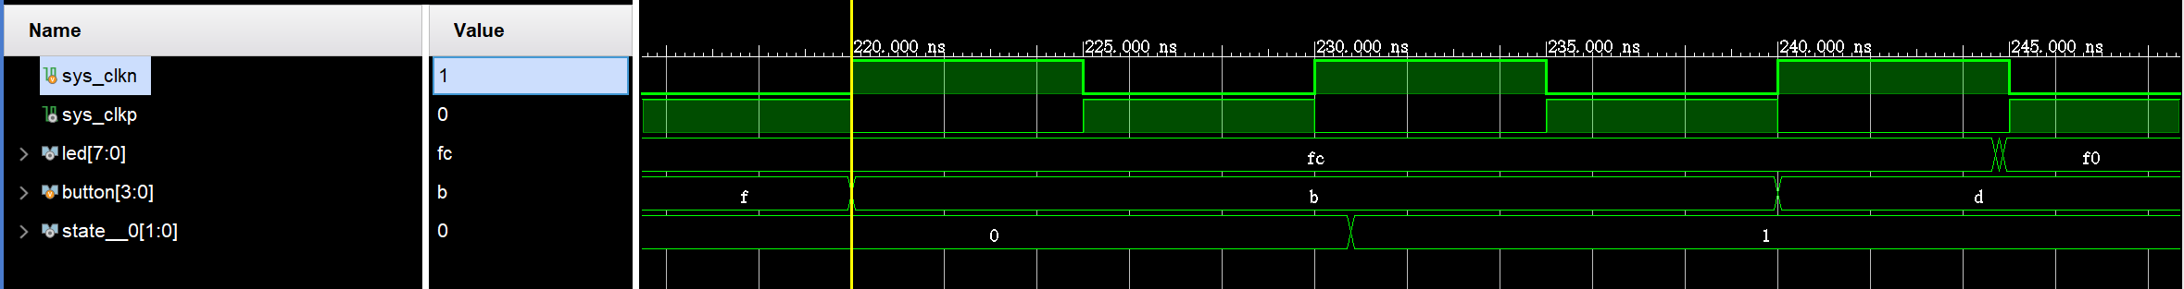
2. It only takes 15 ns for behavioral sim to update, this is possibally due to that change the button is pressed right at the edge of clock, the FPGA might not be able to capture this change in button resulting the change being captured 1 clock cycle later (10ns) than behavioral sim where rising clock while perfectly capture everything.

**Milestone2 Code:**

FSM.V:

`timescale 1ns / 1ps

module FSM

#( parameter one_sec = 100000000,

half_sec = 50000000)

(

input wire clk,

input wire[31:0] pedestrian,

output wire[7:0] led

);

localparam STATE_Y1 = 3'd1;

localparam STATE_G1 = 3'd2;

localparam STATE_Y2 = 3'd3;

localparam STATE_G2 = 3'd4;

localparam STATE_PE1 = 3'd5;

localparam STATE_PE2 = 3'd6;

reg [3:0] state = 0;

reg [7:0] led_register = 0; //R1, Y1, G1, R2, Y2, G2, R3, G3.

reg [27:0] counter = 0;

reg cross = 0;

reg pedestrain_reg = 1; // initialized to 1 to prevent USB set up triggering pedestrian event

assign led = ~led_register; //map led wire to led_register

always @(posedge clk)

begin

pedestrain_reg <= pedestrian[0];

if ((pedestrain_reg == 1'b0) && (pedestrian[0] == 1'b1))

begin

cross <= 1'b1;

end

case (state)

STATE_G1 : begin

led_register <= 8'b00110010;

if (counter >= one_sec)

begin

state <= STATE_Y1;

counter <= 0;

end

else

begin

counter <= counter + 1;

end

end

STATE_Y1 : begin

led_register <= 8'b01010010;

if (counter >= half_sec && cross)

begin

state <= STATE_PE1;

counter <= 0;

cross <= 0;

end

else if (counter >= half_sec)

begin

state <= STATE_G2;

counter <= 0;

end

else

begin

counter <= counter + 1;

end

end

STATE_G2 : begin

led_register <= 8'b10000110;

if (counter >= one_sec)

begin

state <= STATE_Y2;

counter <= 0;

end

else

begin

counter <= counter + 1;

end

end

STATE_Y2 : begin

led_register <= 8'b10001010;

if (counter >= half_sec && cross)

begin

state <= STATE_PE2;

counter <= 0;

cross <= 0;

end

else if (counter >= half_sec)

begin

state <= STATE_G1;

counter <= 0;

end

else

begin

counter <= counter + 1;

end

end

STATE_PE1 : begin

led_register <= 8'b10010001;

if (counter >= one_sec)

begin

state <= STATE_G2;

counter <= 0;

end

else

begin

counter <= counter + 1;

end

end

STATE_PE2 : begin

led_register <= 8'b10010001;

if (counter >= one_sec)

begin

state <= STATE_G1;

counter <= 0;

end

else

begin

counter <= counter + 1;

end

end

default: state <= STATE_G1;

endcase

end

endmodule

lab3_example.v:

`timescale 1ns / 1ps

module lab3_example(

input wire [4:0] okUH,

output wire [2:0] okHU,

inout wire [31:0] okUHU,

inout wire okAA,

output [7:0] led,

input sys_clkn,

input sys_clkp

);

wire [31:0] pedestrian;

wire okClk; //These are FrontPanel wires needed to IO communication

wire [112:0] okHE; //These are FrontPanel wires needed to IO communication

wire [64:0] okEH; //These are FrontPanel wires needed to IO communication

wire clk;

IBUFGDS osc_clk(

.O(clk),

.I(sys_clkp),

.IB(sys_clkn)

);

okHost hostIF (

.okUH(okUH),

.okHU(okHU),

.okUHU(okUHU),

.okClk(okClk),

.okAA(okAA),

.okHE(okHE),

.okEH(okEH)

);

localparam endPt_count = 1;

wire [endPt_count*65-1:0] okEHx;

okWireOR # (.N(endPt_count)) wireOR (okEH, okEHx);

okWireIn wire10 ( .okHE(okHE),

.ep_addr(8'h00),

.ep_dataout(pedestrian));

FSM FSM(.clk(clk),

.pedestrian(pedestrian),

.led(led));

endmodule

lab3_TestBench.v:

`timescale 1ns / 1ps

module lab3_TestBench();

//Declare wires and registers that will interface with the module under test

//Registers are initilized to known states. Wires cannot be initilized.

reg clk = 1;

wire [7:0] led;

reg [31:0]button;

//Invoke the module that we like to test

FSM#(.one_sec(100),.half_sec(50)) ModuleUnderTest (.pedestrian(button),.led(led),.clk(clk));

// Generate a clock signal. The clock will change its state every 5ns.

//Remember that the test module takes sys_clkp and sys_clkn as input clock signals.

//From these two signals a clock signal, clk, is derived.

//The LVDS clock signal, sys_clkn, is always in the opposite state than sys_clkp.

always begin

#5 clk = ~clk;

end

initial begin

#0 button <= 0;

#4000 button <= 1;

#500 button <= 0;

#2000 button <= 1;

end

endmodule